**JavaFX Data Entry Form Application**

**Project Overview**

This project is a **JavaFX-based Data Entry Form Application** designed to collect and display personal details in a user-friendly graphical interface. It incorporates JavaFX components such as text fields, combo boxes, radio buttons, and alerts for efficient data collection and feedback.

**Features**

1. **Graphical User Interface (GUI):**
   * Intuitive layout using **JavaFX controls**.
   * A banner image at the top for branding or aesthetic purposes.
   * Form inputs for personal information like name, father's name, CNIC, date of birth, gender, and city.
2. **Form Data Input:**
   * Text fields for entering **Name**, **Father's Name**, and **CNIC**.
   * A **DatePicker** control for selecting the **Date of Birth**.
   * **Radio buttons** for selecting gender with a toggle group to enforce single selection.
   * A **ComboBox** for choosing the city from a predefined list.
3. **Image Upload:**
   * A **file chooser** allows the user to upload and display a personal image within the form.
4. **Form Submission:**
   * Saves the entered details in a Person object and adds it to a list for data management.
   * Displays a confirmation window upon successful submission.
5. **Printing Form Details:**
   * Displays the submitted data in a formatted alert box using monospaced font for proper alignment.
   * The toString method of the Person class ensures data is presented neatly.

**Key Classes and Their Responsibilities**

**1. Person Class**

* Represents the structure of the data model.
* Contains private fields for the following attributes:
  + Name
  + Father's Name
  + CNIC
  + Date of Birth
  + Gender
  + City
* Implements the toString() method to format the data in a readable, aligned structure.

**2. HelloApplication Class**

* Implements the main GUI logic.
* Manages form layout using JavaFX components, including:
  + GridPane for organizing form elements.
  + VBox and HBox for overall layout management.
* Handles events for:
  + Saving form data.
  + Printing form details.
  + Closing the application.

**Project Structure**

* **com.example.labassignment2 Package**:
  + Contains the Person and HelloApplication classes.
* **Assets**:
  + images/banner_image.jpg: Used as the banner image for the application.

**How to Run the Application**

1. Place the banner_image.jpg in the images folder relative to the project directory.
2. Build and run the project in an IDE with JavaFX support (e.g., IntelliJ IDEA or Eclipse).
3. Fill out the form and click **Save** to submit data.
4. Click **Print Form** in the confirmation window to view the submitted details.

**Sample Output**

**GUI Form:**

* Fields for name, father's name, CNIC, date of birth, gender, and city.
* Upload option for a profile image.

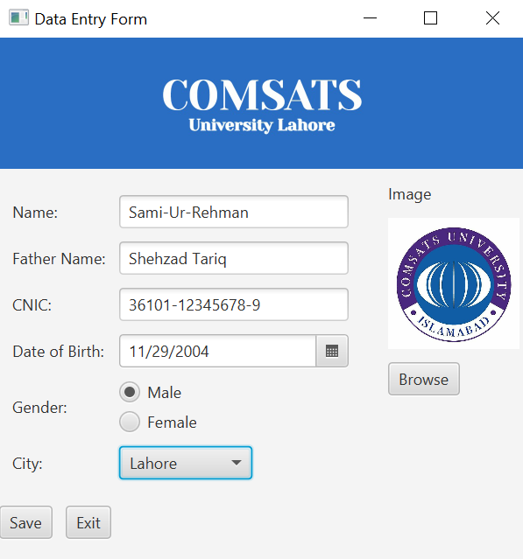

**Form Submission:**

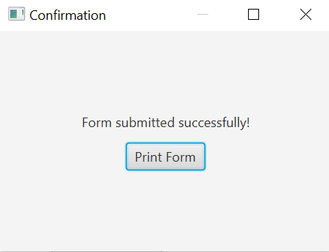

**Printed Form**

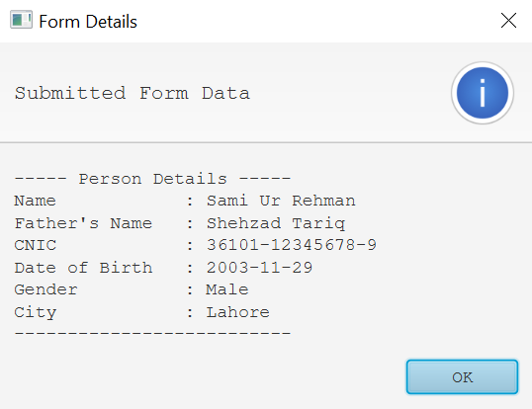

Used Mono-spaced font ‘Courier New’ to have the alignment in form data..